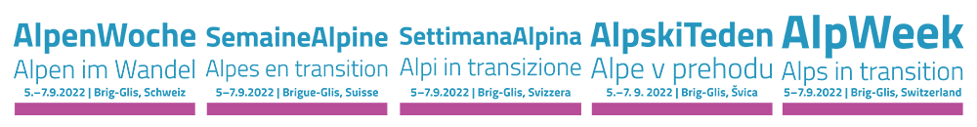

Schaan, August 18th 2022

Press release to the AlpWeek 2022 in Brig-Glis/CH

Alps in transition

**The ecological transition is already happening in the Alps – and we are in the middle of it. The AlpWeek 2022 from 5 to 7 September 2022 in Brig-Glis/CH will bring together citizens and decision-makers to discuss the many aspects of transformation in the Alps. CIPRA is co-organiser of the international event.**

In order to face the unprecedented environmental and sustainability challenges ahead, we need to change our lifestyles and rethink our energy consumption, our production methods, our food supply... Beyond the energy, economic and agri-food transitions, many other sectors such as tourism and mobility are experiencing transitions that have a massive impact on social life and the demographic structure of alpine communities.

These topics – and many more – are explored during the AlpWeek 2022 in Brig-Glis. There is no single solution but rather many different approaches to the ecological transition in the Alps. Quality of life, carbon-friendly living, and citizen participation will be at the core of the solutions we will develop during the AlpWeek.

**Multifaceted programme**

Participants can expect inspiring lectures on grassroots innovations and citizen cooperatives, a panel discussion on photovoltaics in the landscape, as well as twelve interactive workshops that address transition in a wide range of areas: from climate change and migration to energy efficiency, water integration in cities and mountain farming. In addition, there will be inputs from young people, exciting excursions and a cultural evening programme. The keynotes and the panel discussion will be simultaneously translated into all Alpine languages. Interested people and the local population can also participate in individual programme items. The excursions for example will take the participants to the Simplon Pass and the Aletsch Glacier, or focus on viticulture and biodiversity in Salgesch and the traditional Valais agricultural landscapes in Brig-Glis. The panel discussion on Tuesday evening is free of charge and open to the public without registration.

**Shaping change**

The AlpWeek is an international event co-organised by the leading Alpine organisations committed to mountain protection and sustainable development. Young people, members of nonprofit organisations, researchers or civil servants, media professionals, politicians and Alpine inhabitants are all invited to take part in AlpWeek and contribute their ideas for shaping transition in the Alps.

Programme and registration: [www.alpweek.org](http://www.alpweek.org)

***Organisers:***  
Alliance in the Alps, Alpine Convention, Interreg Alpine Space programme, Alpine Town of the Year Association, CIPRA Switzerland, CIPRA International, Club Arc Alpin, Swiss Alpine Club, ISCAR Alpine Research, Forum Landscapes, Alps, Parks.

This release and print-ready photographs are available for downloading from <https://www.cipra.org/en/media-releases>

Further information:

Caroline Begle, CIPRA International, +423 237 53 53, [caroline.begle@cipra.org](mailto:caroline.begle@cipra.org)

**CIPRA, a diverse and multifaceted organisation**

CIPRA, the International Commission for the Protection of the Alps, is a non-governmental umbrella organisation with national representatives and one regional representative in the seven Alpine countries. It represents more than 100 associations and organisations. CIPRA works towards achieving sustainable development in the Alps; it also strives to preserve the natural and cultural heritage, maintain regional diversity, and bring about solutions to cross-border problems in the Alpine region. [www.cipra.org](http://www.cipra.org)